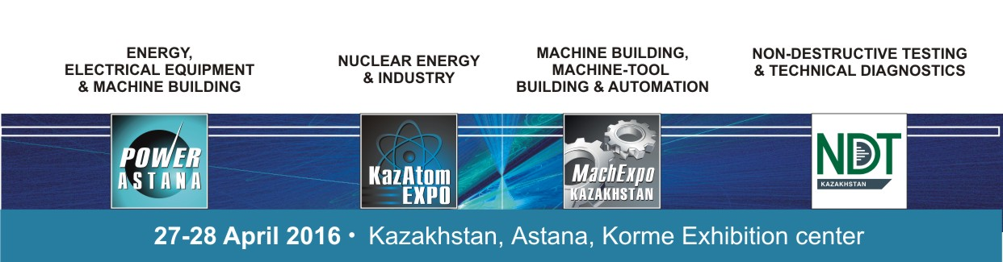
EXHIBITORS LIST:

POWER ASTANA
MACHEXPO KAZAKHSTAN
KAZATOMEXPO
NDT KAZAKHSTAN

KAZAKHSTAN:
- ASSOCIATION OF KASAKHSTAN MASHINERY INDUSTRY
- ASTANA ELECTROTECHNICAL PLANT, LLP
- ASTANA TECHNOLOGICAL CENTRE, LLP
- INTERCOMMERTZ, LLP
- KARLSKRONA LC AB
- KAZAKHSTAN ELECTRICITY ASSOCIATION
- KAZAKHSTAN ENERGY AUDIT ASSOCIATION
- KAZIZOTOP, LLP
- KEMONT
- KOBOLD INSTRUMENTS, LLP
- LAPP KAZAKHSTAN, LLP
- NILED-KAZAKHSTAN, LLC
- PROTECT NPO, LLP
- SAVOIR FAIRE, ТОО
- TALDYKORGAN CABLE PLANT, LLP
- TESLA, LLP
- THE KAZAKHSTAN ASSOCIATION OF NON-DESTRUCTIVE TESTING AND TECHNICAL DIAGNOSTICS (KANKTD)
- АККЕ KAZAKHSTAN, LLP
RUSSIA:
- ACOUSTIC CONTROL SYSTEMS, LTD
- ALL-RUSSIA RESEARCH INSTITUTE OF AUTOMATICS N.A. N.L.DUKHOV, FEDERAL STATE UNITARY ENTERPRISE
- ASE GROUP
- CABLE ALLIANCE HOLDING, CORPORATION
- CHEBOKSARY ELECTRICAL APPARATUS PLANT
- ELECTRONIC INFORMATION SYSTEMS, SCIENTIFIC AND PRODUCTION ENTERPRISE, CJSC
- ELECTROTECHNICAL FACTORIES “ENERGOMERA”, JSC
- EM-CABEL LTD.
- ENGINEERING CENTER OF ENERGY SAVING LIGHTING TECHNOLOGY
- FIRMA SPRUT, LTD
- INCAB
- INTERNATIONAL URANIUM ENRICHMENT CENTRE, JSC
- INVERTOR FACTORY, JSC
- LABARA-RUS
- LISMA, S.U.E. OF THE REPUBLIC OF MORDOVIA
- MASHINOSTROITELNY ZAVOD, РJSC
- MATRITCA, LTD.
- NON-DESTRUCTIVE TESTING,GROUP OF COMPANIES
- POWER MACHINES, OJSC
- RADIOACTIVE WASTE MANAGEMENT ENTERPRISE «ROSRAO»,FSUE
- REAL STEEL, LTD
- ROSATOM
- STRIJ TELEMATICS
- THE INSTITUTE OF LIGHT SOURCES NAMED A.N. LODYGIN
- ZETO, PLANT OF ELECTROTECHNICAL EQUIPMENT

GERMANY:
- GUHRING UG
- GREEN ENERGY 3000

CHINA:
- JIANGSU SFERE ELECTRIC CO., LTD

BELARUS:
- ENERGOCOMPLEKT PA, LTD.

SWITZERLAND:
- ALFLETH ENGINEERING

CZECH REPUBLIC:
- TOSHULIN a.s.

ITALY:
- GIOVENZANA INTERNATIONAL B.V.

SINGAPORE:
- ARISE GLOBAL PTE, LTD

